Bethel Elementary
First Grade Supply List for 2016-2017
- Book Bag (no wheels)
- Plastic Pocket Folder w/ Middle Clasp (2)
- White 3-Ring 1” Binder w/ Clear Front
- Clip Board
- Box of Colored Pencils
- 1 pack of thin dry erase markers
- Marble Composition Book (3)- Primary Ruled
(see picture below)

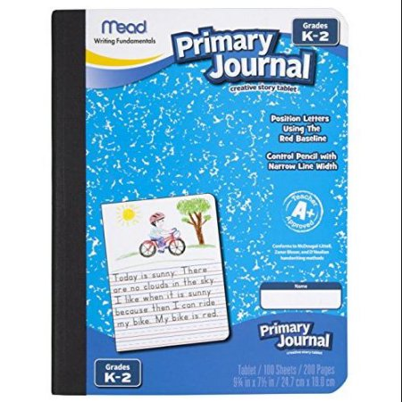

First Grade Teaching Supply List for 2016-2017
- Manila Long Chart paper (Separate sheets)
- Sentence Strips (Bright colors) 1 pack per teacher
- Lined Handwriting paper (Example attached): 5/8” Ruling, 5/16” Descender Space, Red Baseline, Blue Headline
- Large Sticky Post-It charts (Easel Pad)- at least 1 per teacher
- Small 1 ½ inch ruled charts (White Paper)
- 1 Subscription to Ranger Rick Jr. Magazine for Each first grade classroom
- National Geographic Young Explorer for each child
- Highlighter Tape
- Post-it: Labeling & Cover-up tape (White rolls)
- Large Binder Clips (30 per classroom) to clip agenda books
- White out for teachers
- Card stock of any color
- Manilla folders ( class set for each teacher)
- Tissue paper
- Sharpie chart markers
- Lucy Caulkin’s Readers Workshop sticky notes for each unit- can be printed online

*Need more white construction paper (White ran out quickly this past year and it was hard to find some)

