2017-2018 Bethel Elementary Kindergarten Supply List
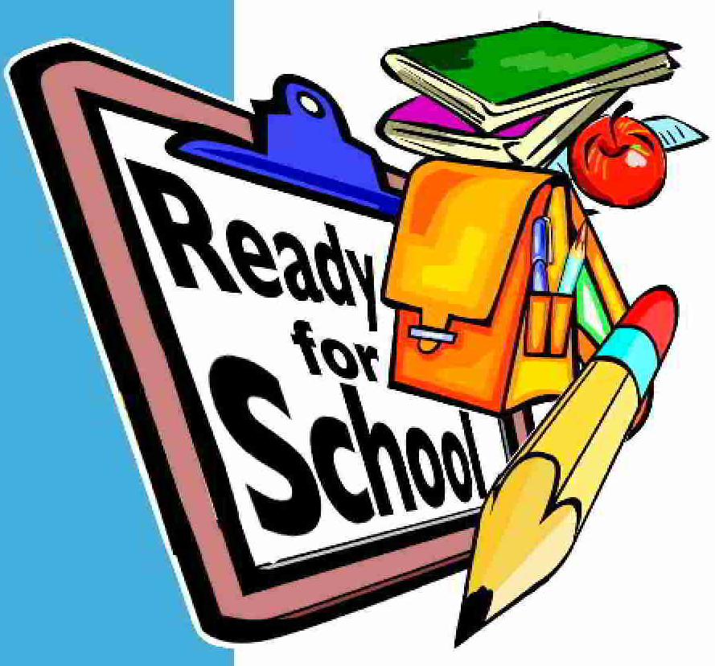

1 composition notebook
1 one-subject spiral notebook
1 two-pocket folder without prongs
1 three-ring, 1-inch binder
1 pack of slash pocket dividers (to fit 3 ring binder)
12 glue sticks
1 box gallon-sized Ziploc bags (girls)
1 box quart-sized Ziploc bags (boys)
rest mat
large backpack without wheels

