Should I be worried about my child’s speech?

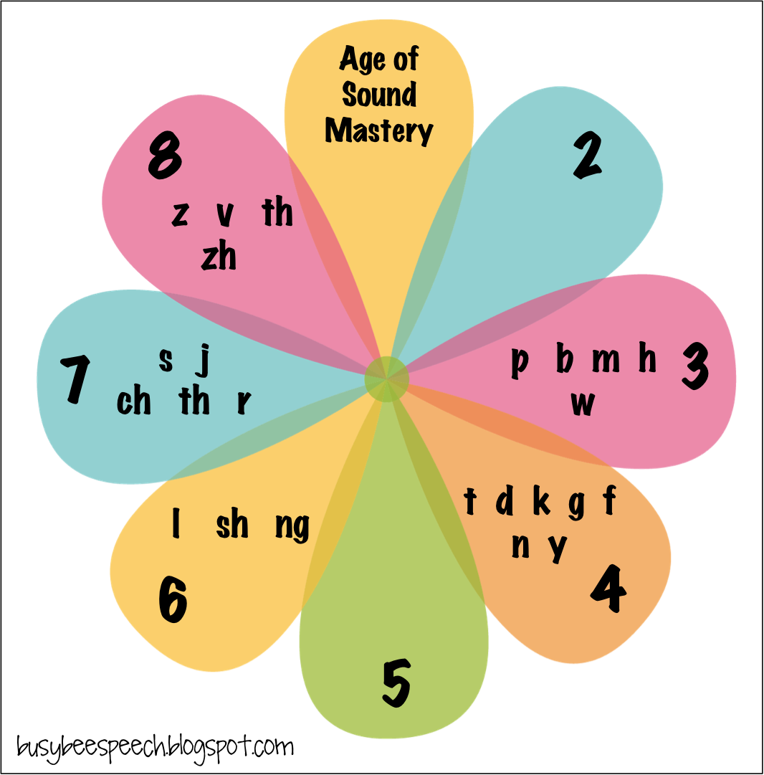

Remember: children NORMALLY develop some sounds much later than others. This chart can help you know when to be concerned (or not!!) about sound errors your child may exhibit.

