Bethel Elementary
Second Grade Supply List

2 packs of crayons
8 glue sticks
1 pair of scissors
1 pack of 24 pencils
1 pack of pink erasers (no eraser caps please)
1 plastic pencil box
2 plastic pocket folders
1 stack of 3x3 post-it notes
3 marble composition books

Marble composition book-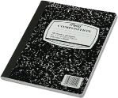

Pink erasers- 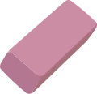

3x3 post-it notes-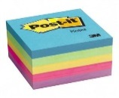

Plastic pencil box- 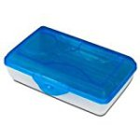

Thank you for your support!

