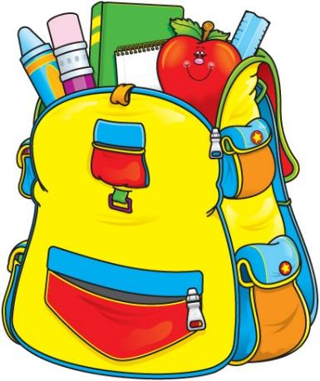

Bethel Elementary School
1st Grade Supply List

- 1- 1 inch binder
- 4- Primary Ruled K-2 composition books (marble cover)
- 4- 2 pocket, 3 prong plastic folders
- 1 pack- Ticonderoga Pencils
- 1 pack- big pink erasers (2 or more erasers in the pack)
- 1 pack- colored pencils
- 1 pack- crayons
- 1 pack- markers
- 12- Glue sticks
- 1 pack- highlighters
- 1 pack- skinny black dry erase markers
- Kleenex
- Clorox Wipes
- Hand sanitizer
- Ziploc Bags: Boys- Quart Size, Girls- Gallon Size
- 1 pair of headphones or earbuds
- Band-aids (assorted sizes)

